Yes, you are right. This is what I got when the transaction file was exported from the transaction system.

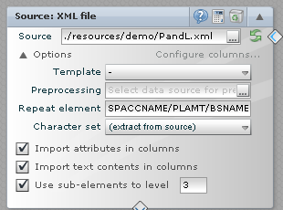

In view of this, I did not have much info reg the header and other details. When I input this in the source field and used the repeat element as given in the XML file, I get the error message given below

