**Core Components of an Enterprise BPMN Collaboration Diagram** (Start Event, Activity, End Event, Intermediate Event, Call Activity)

**Problem Statement**: During the creation of a BPMN process, when the user starts to name any of the above-mentioned objects after placing it in the blank space, as soon as the user starts typing, ARIS shows a drop-down with similar named objects that are already existing. If the user selects an option from the drop-down, it gets selected and becomes an Occurrence Copy of an existing object from a different process.  
  
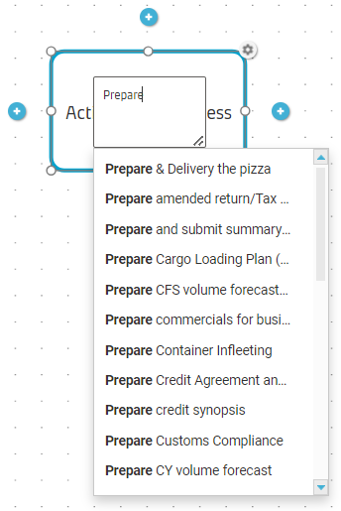 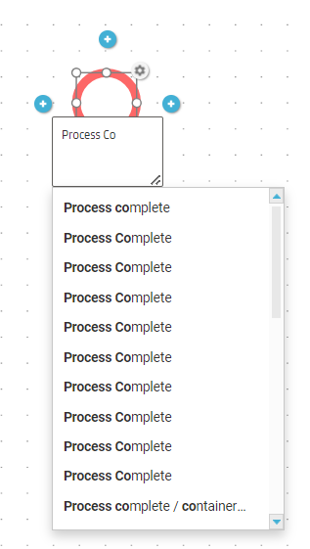 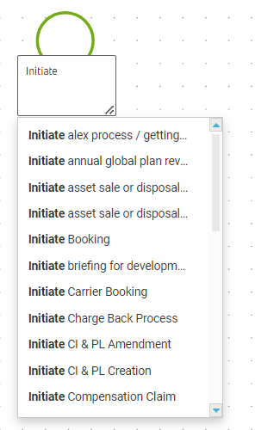  
  
**Solution Required**: Can we configure ARIS where we can hide these dropdowns from appearing so that each object is created as a definition copy?

**Catalog/Library Components of an Enterprise BPMN Collaboration Diagram** (Roles, Applications)

**Problem Statement**: For Catalog objects, when the user starts to name any of the above-mentioned objects after placing it in the blank space, as soon as the user starts typing, ARIS shows a drop-down with similar named objects that are already existing. This list contains objects from the catalog along with the ones which were created accidently by users (which should not be used)  
  
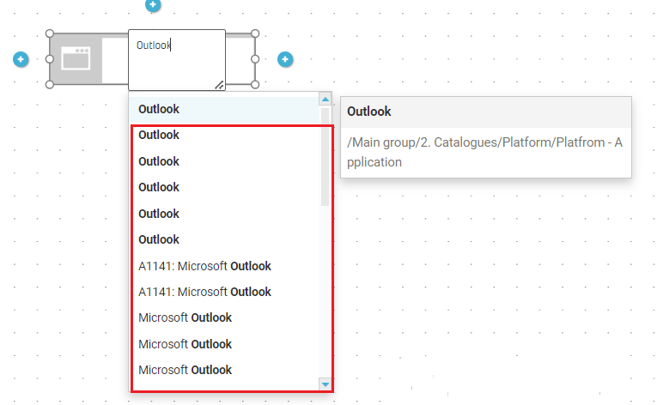

**Solution Required:** Can ARIS be configured in such a way that on typing, only the catalog items should appear in the drop-down, and all the other objects (not created in catalog path) don’t